**FLUTTER FINAL TASK**

**FITVISION-A FITNESS TRACKING APP**

* FitVision is a fitness tracking app built with Flutter.
* Helps users do exercises, monitor their fitness activities, nutrition intake, and progress.
* Integrates Firebase for data storage and multiple APIs for real-time information(Quotes API, Exercise API, Nutrition info API).
* Offers an interactive and visually appealing UI with animations and charts.

Secure login via Firebase authentication.

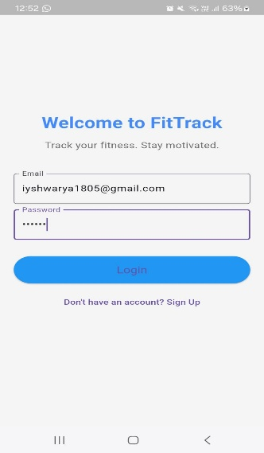

* Home page elements:
  + "Get Motivation" button fetches and displays quotes from API.
  + Weight tracker card for logging weight with date selection.
  + Animated fitness icons enhancing the UI.
  + Language selection feature using flutter_localizations.
  + Drawer navigation with links to Exercises, Nutrition, Challenges, Rewards, Safety Tips, and Progress Charts.

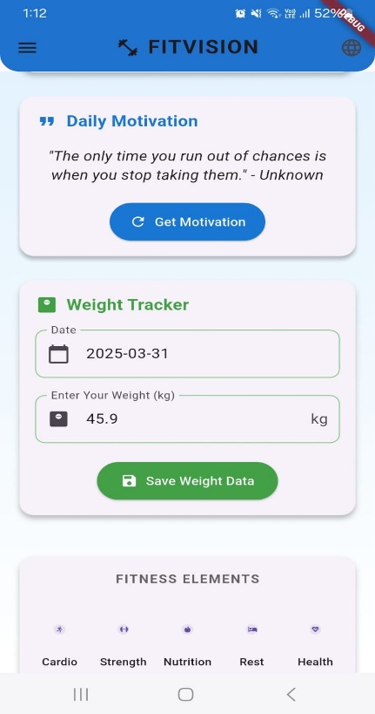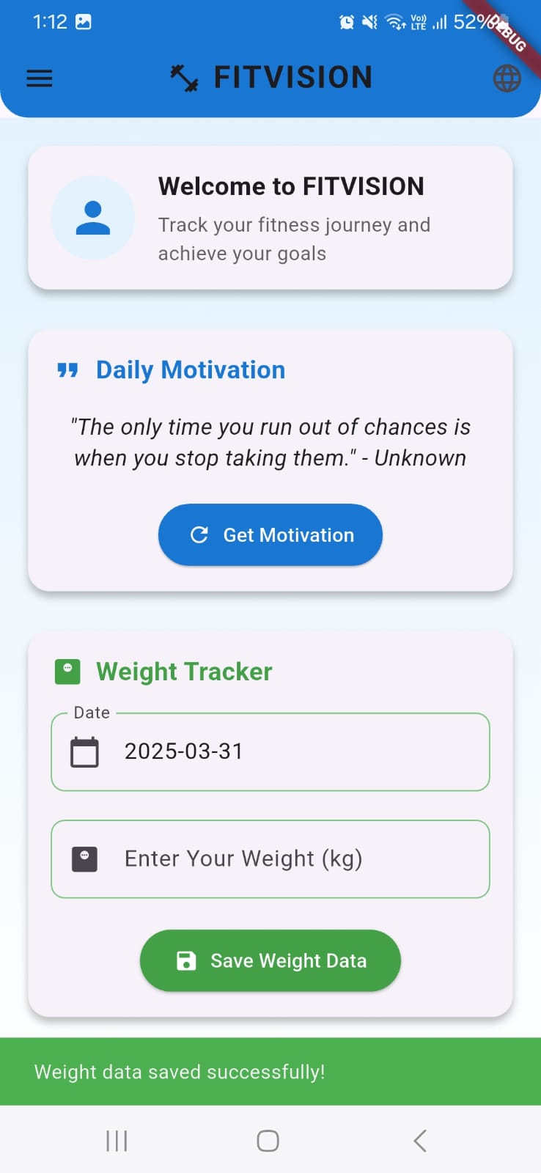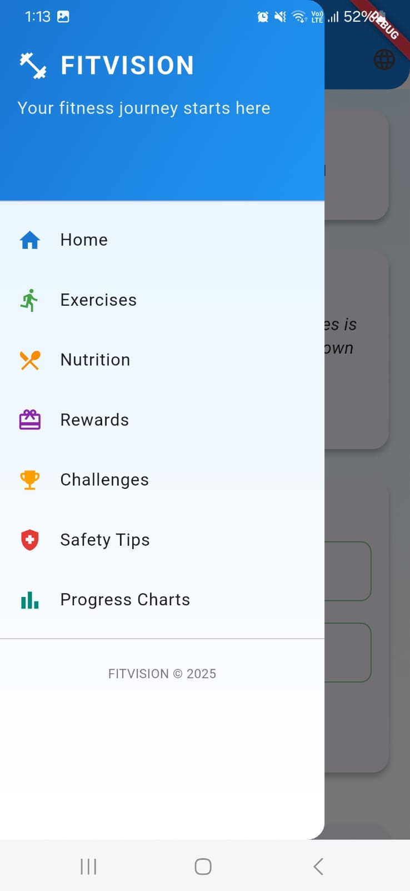

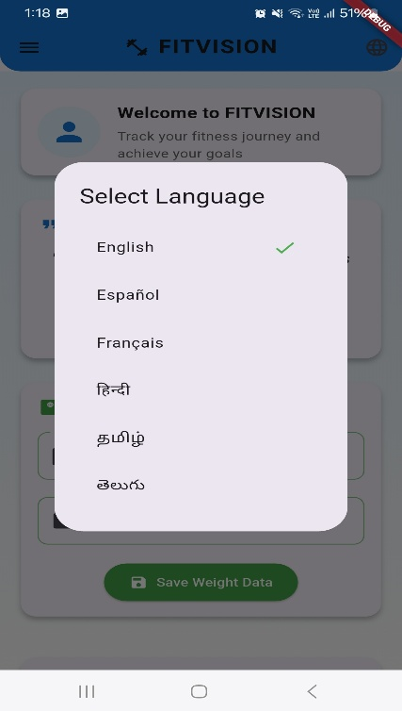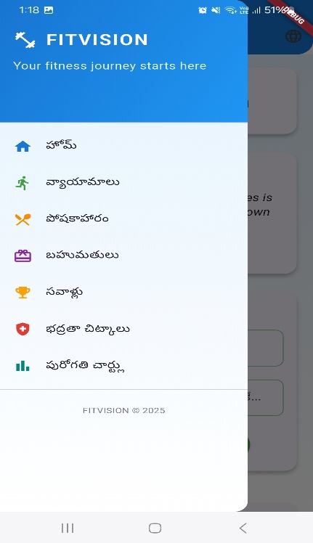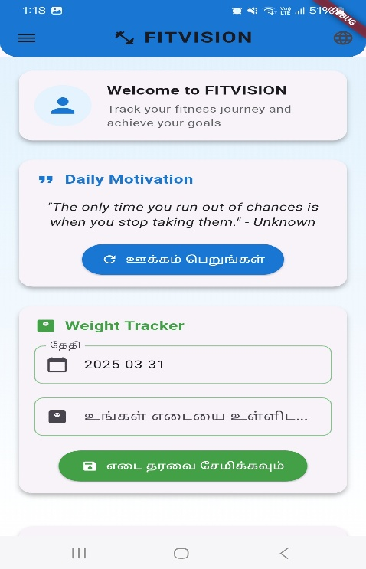

API CALLS

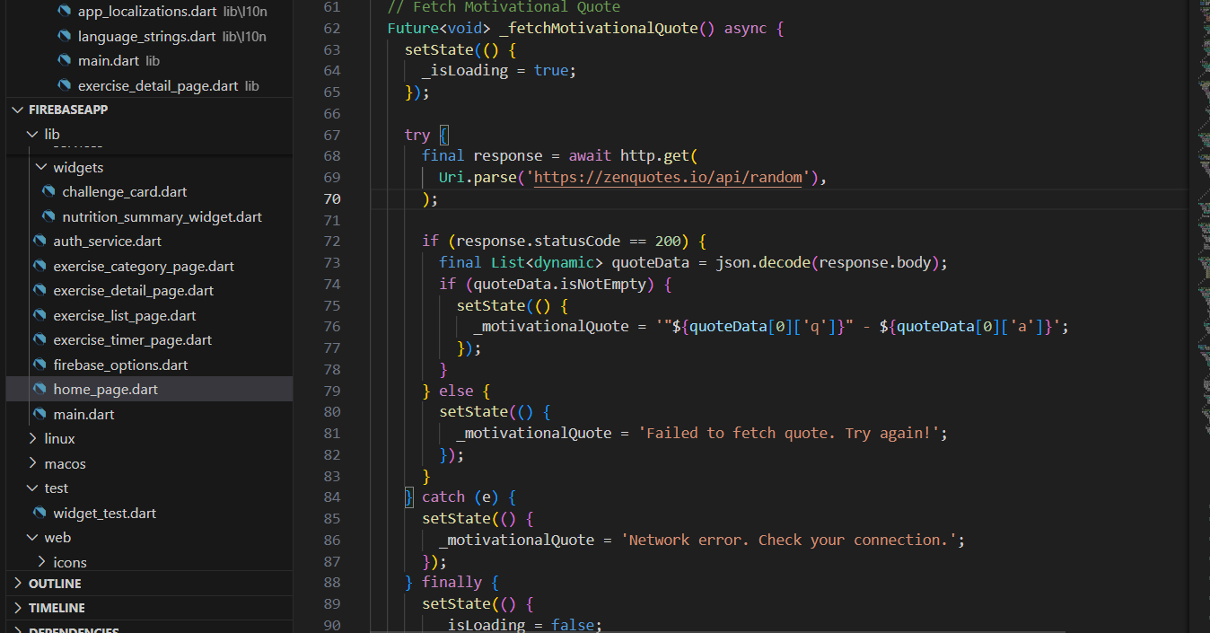

LOCALISATION

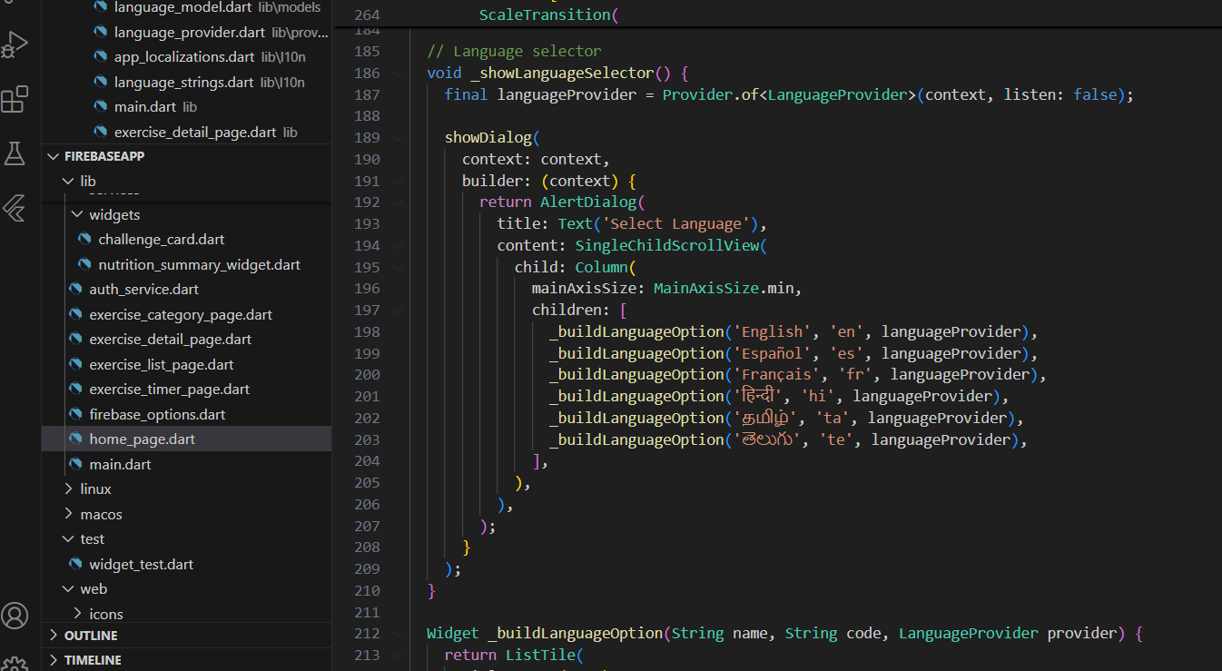

FIRESTORE DATABASE STORAGE

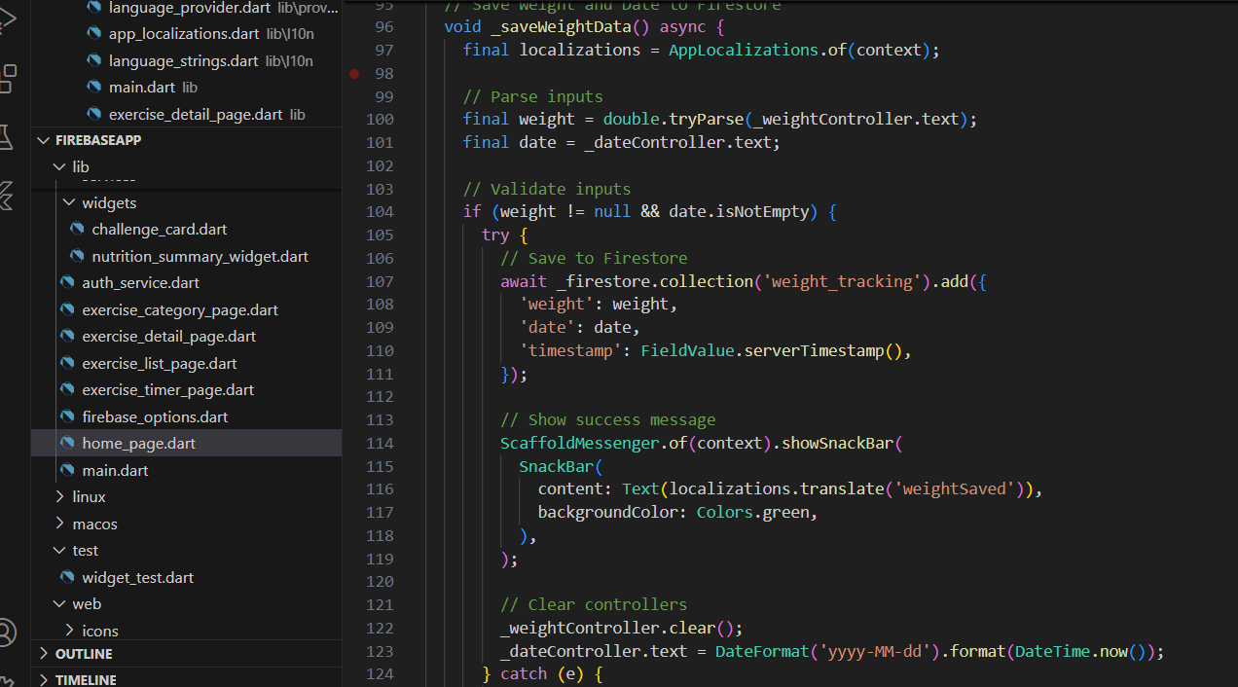

EXERCISE PAGE

* Exercises are categorized into Chest, Back, Shoulders, Abs, etc.
* Clicking on a category lists different exercise types with descriptions fetched via API.
* The "Start Exercise" button begins a 30-second countdown timer.
* Upon completion, an alert appears: "Exercise Completed – Great Job!"
* All completed exercises are stored in Firestore for progress tracking.

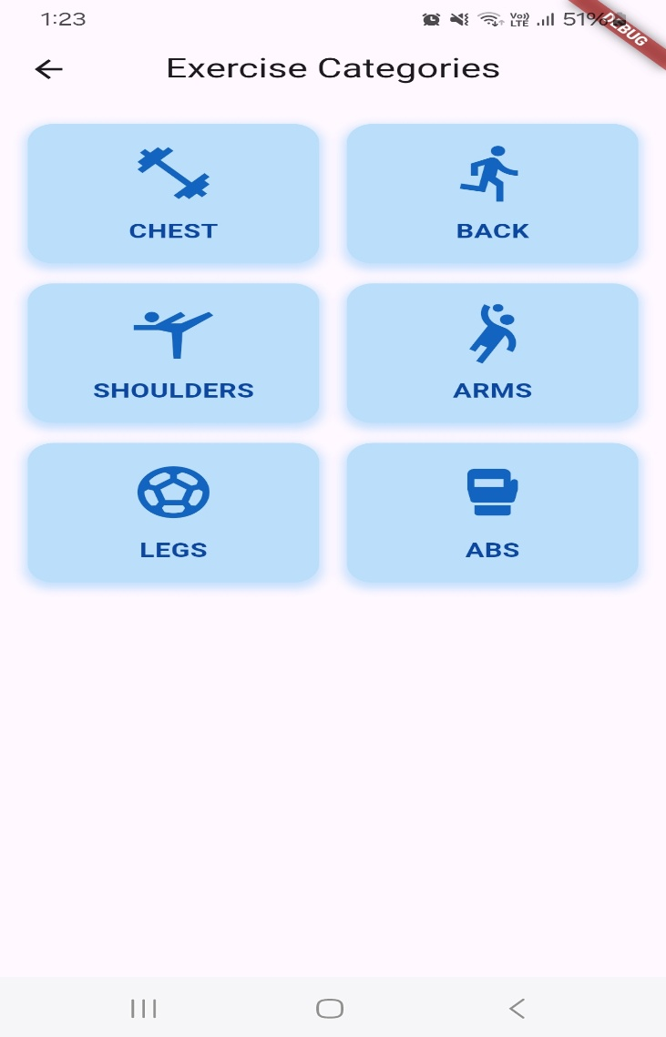

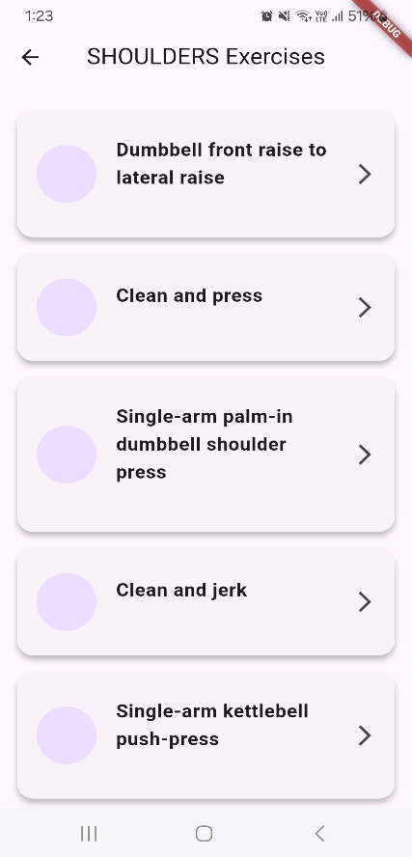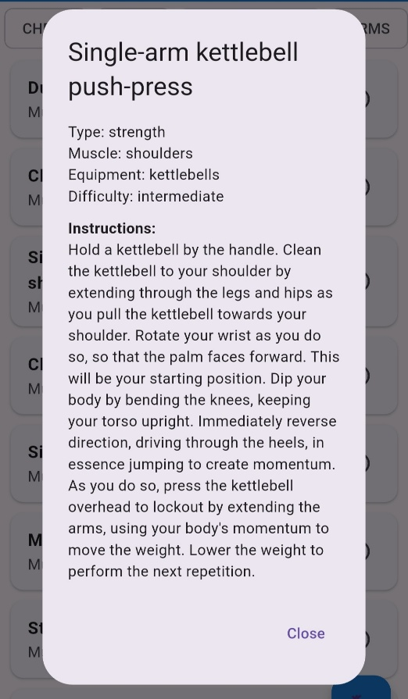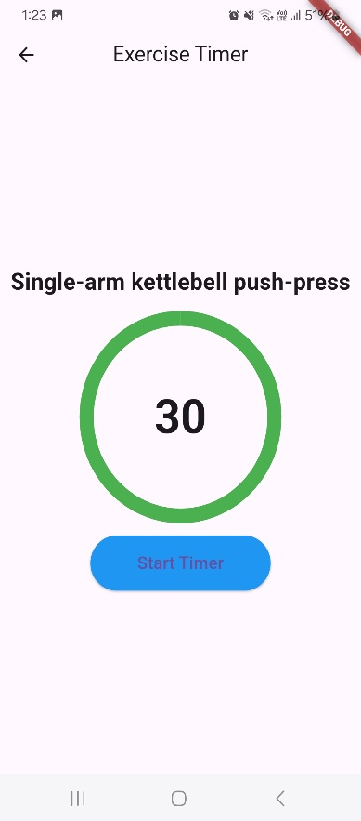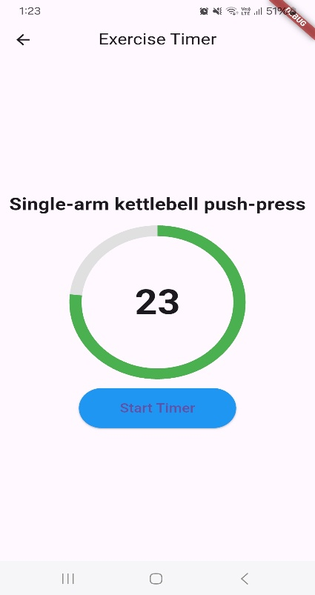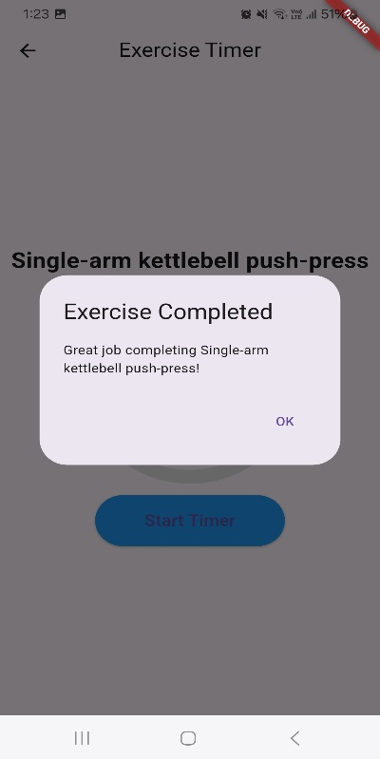

DB UPDATION

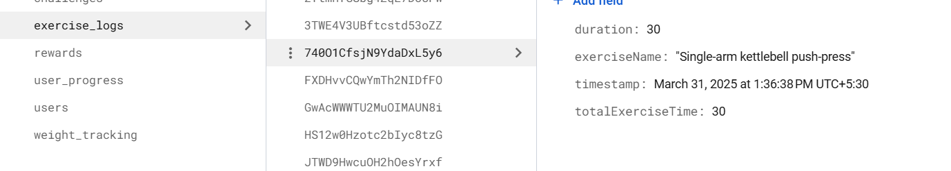

**NUTRITION TRACKING PAGE**

* Nutrition section includes a search bar where users can enter food items (e.g., "1 cup rice").
* The app fetches nutritional details from an API in real time.
* Displays comprehensive nutrition data, including calories, macronutrients, and additional nutrient information.
* Helps users track their dietary intake and make informed nutritional choices.

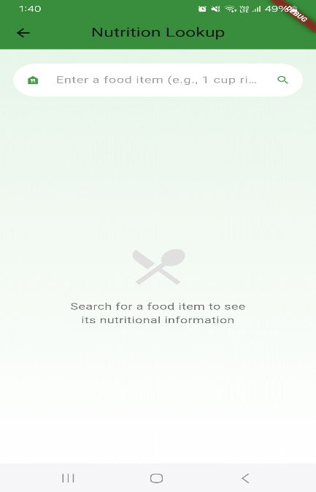

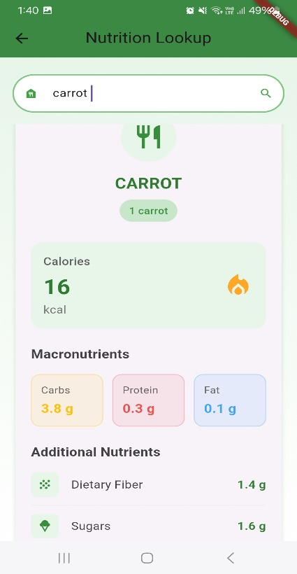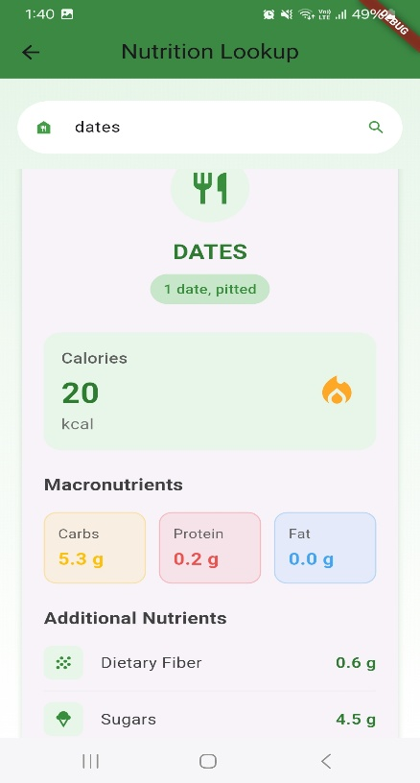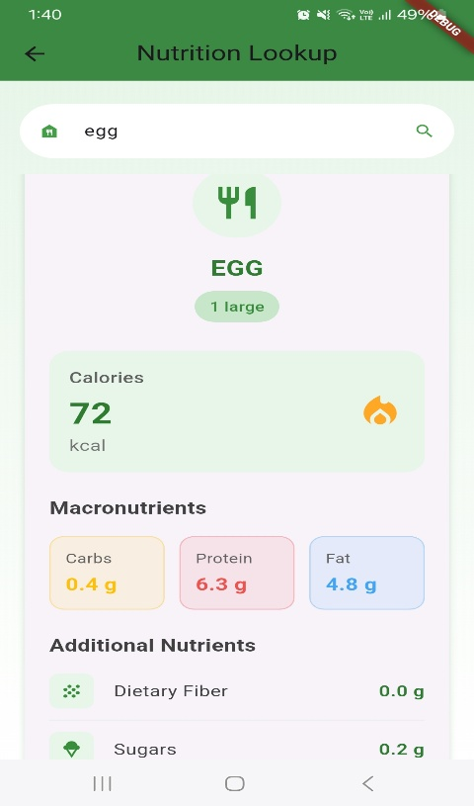

**CHALLENGES PAGE**

* Challenges page displays assigned challenges, such as "Run 5K within 30 minutes," along with their respective rewards (e.g., free protein shake, running badge).
* A "Mark Completed" button allows users to confirm completion, updating the Firestore database in real time.
* Currently, two challenges are available, with a plus (+) icon enabling users to add the same challenge for the next month and complete it again.
* Uses Firebase for data storage, custom styling for an engaging UI, and seamless database integration for tracking user progress.

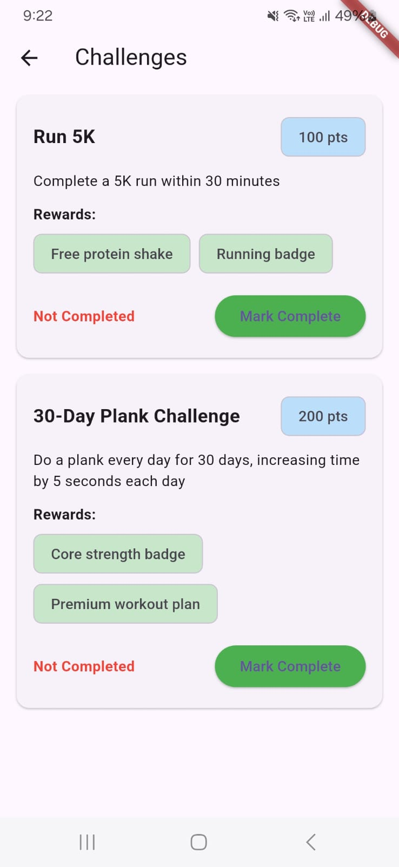 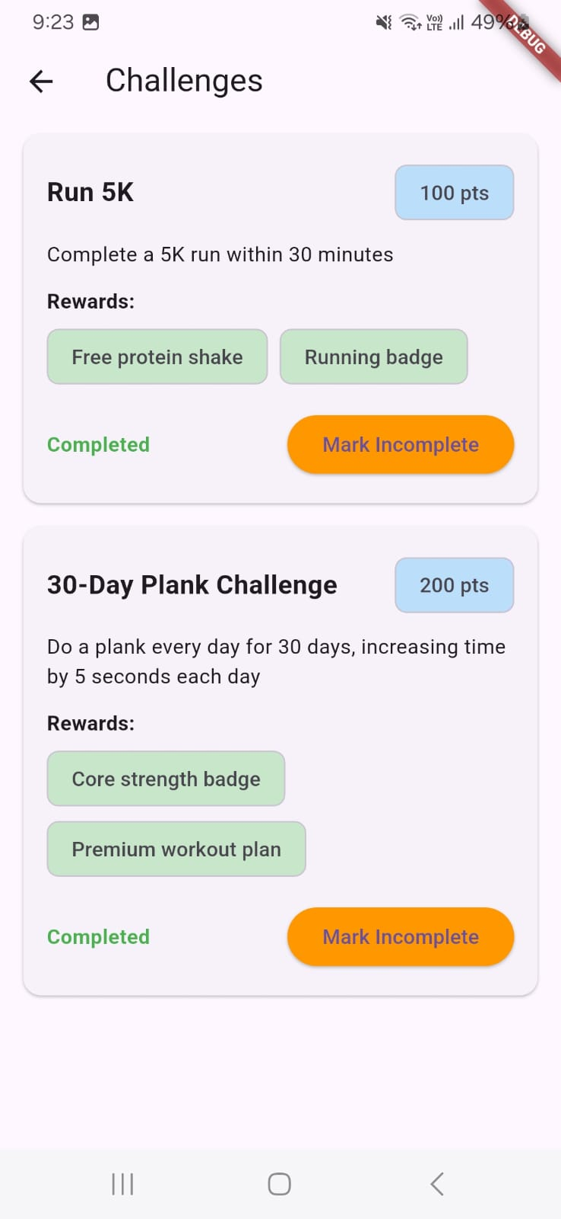

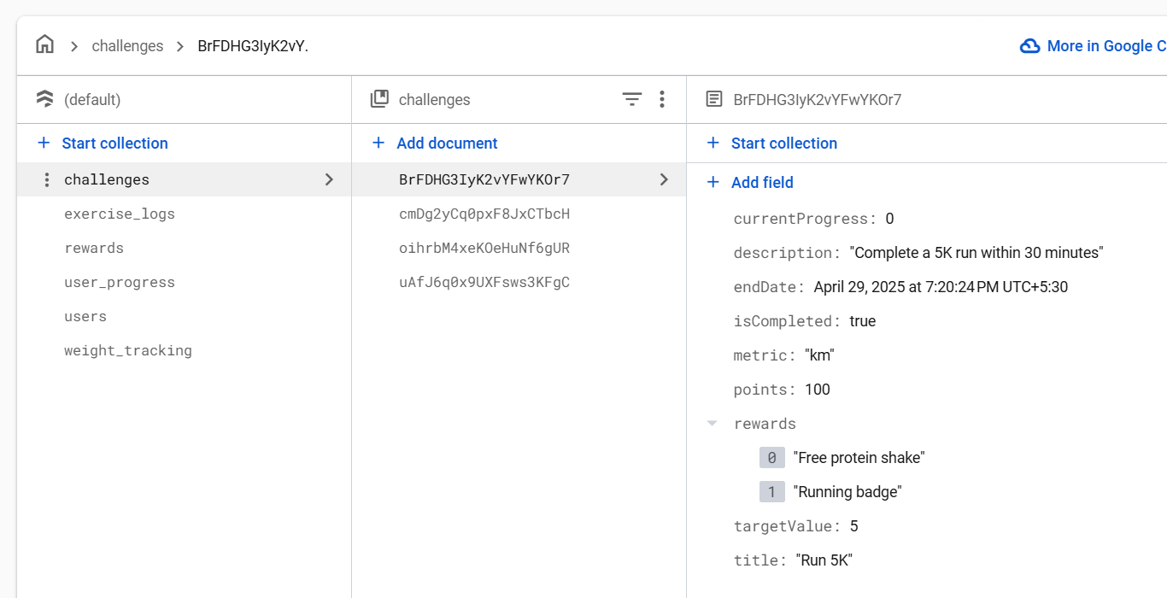

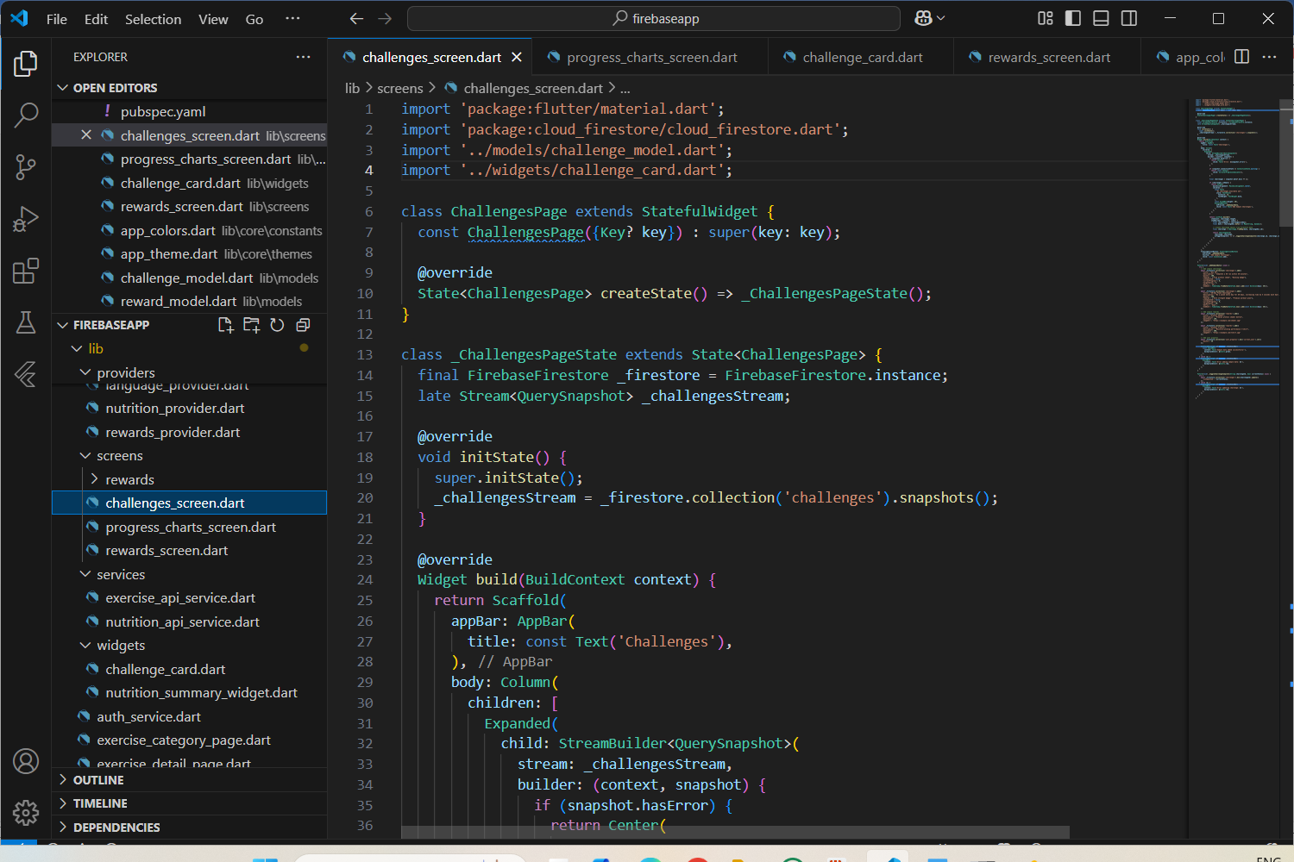

**REWARDS PAGE**

* Tracks earned and redeemable rewards, such as a free protein shake, based on completed challenges.
* Displays available rewards with required points, helping users see what they can achieve next.
* Shows total reward points accumulated, motivating users to complete more challenges.

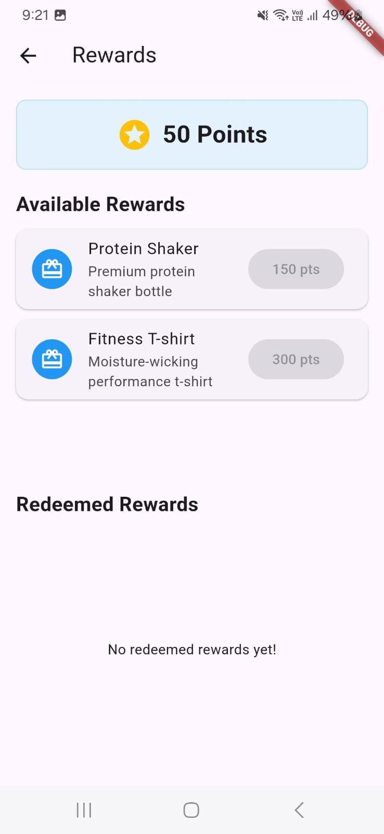

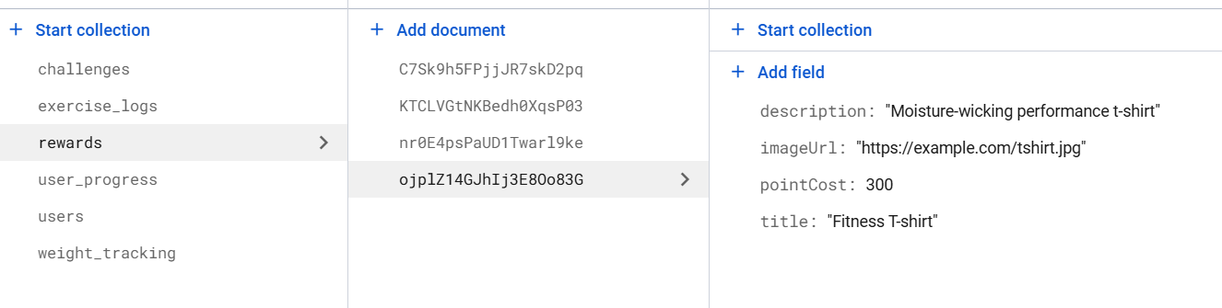

**PROGRESS CHARTS PAGE**

* Visual representation of fitness data using fl_chart.
* Line graph for workout duration.
* Bar graph for calories burned.
* Pie chart for exercise type distribution.
* Progress insights with icons and color-coded UI

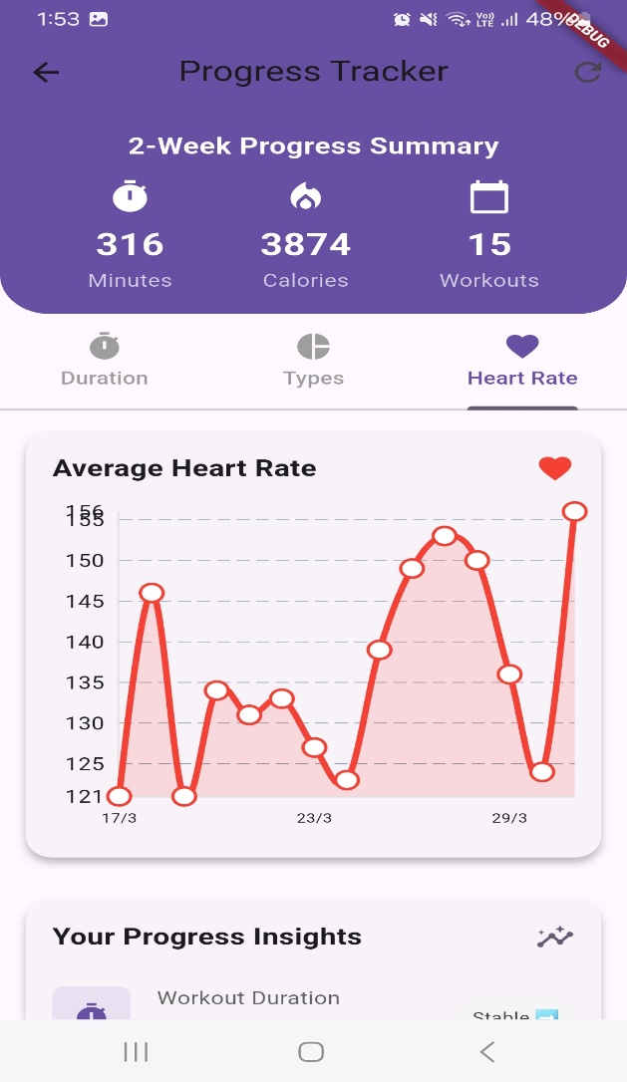 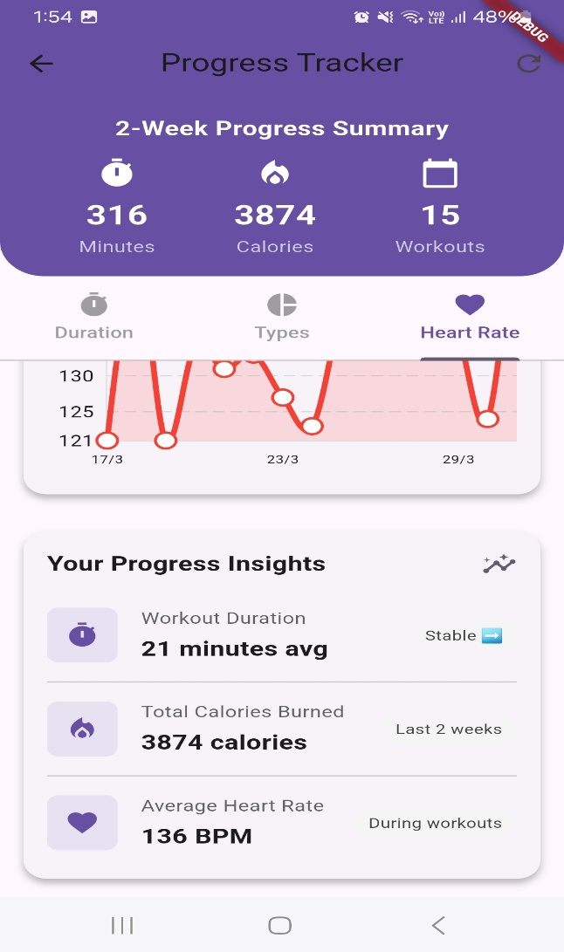

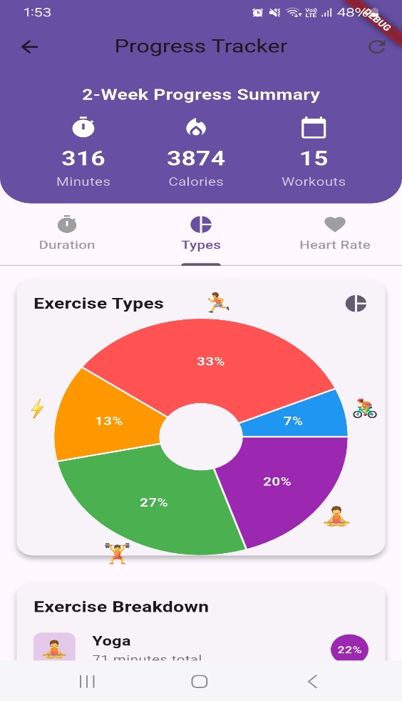 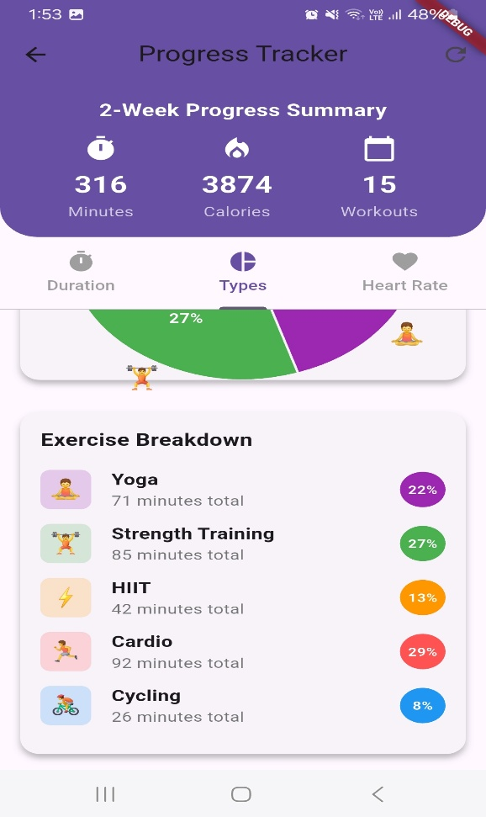

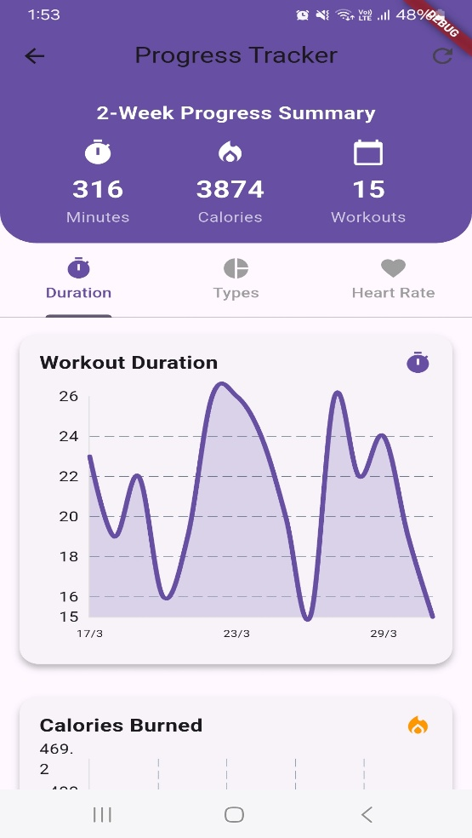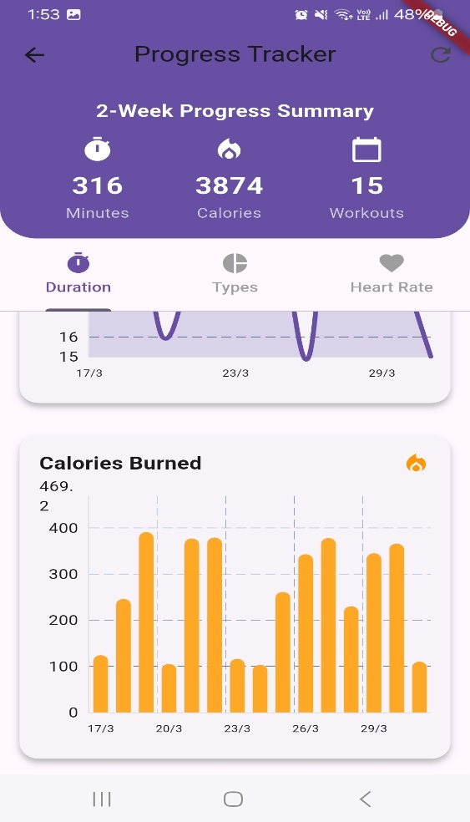

**SAFETY TIPS**

* The Safety Tips page is built using stateless widgets, ensuring a smooth and efficient UI.
* Displays essential fitness guidelines, such as "Stay Hydrated," "Listen to Your Body," and "Rest and Recovery."
* Encourages a balanced routine, helping users prevent injuries and maintain long-term fitness.
* Uses widgets and gestures to enhance user interaction, allowing smooth navigation and engagement.

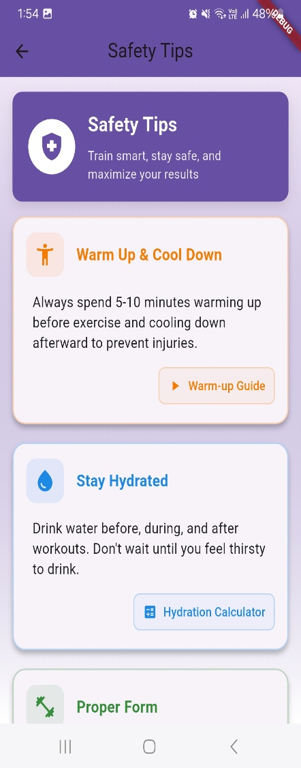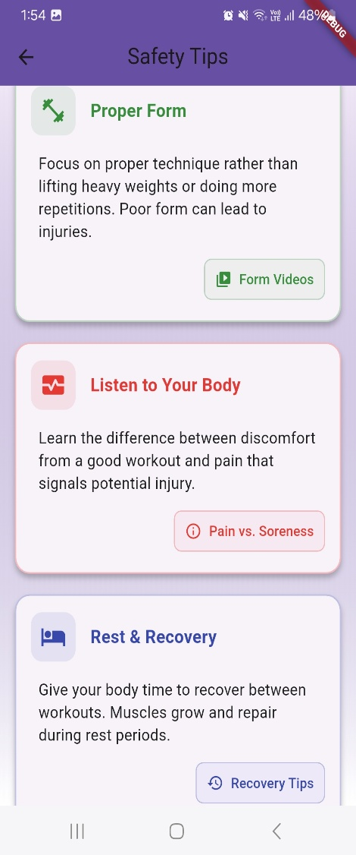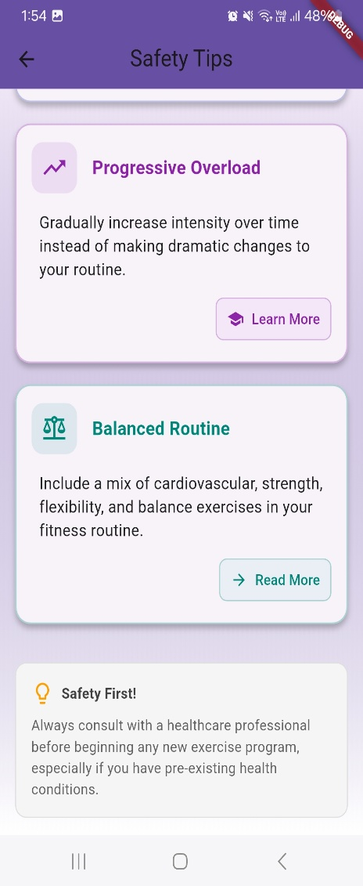

DEPENDENCIES USED:

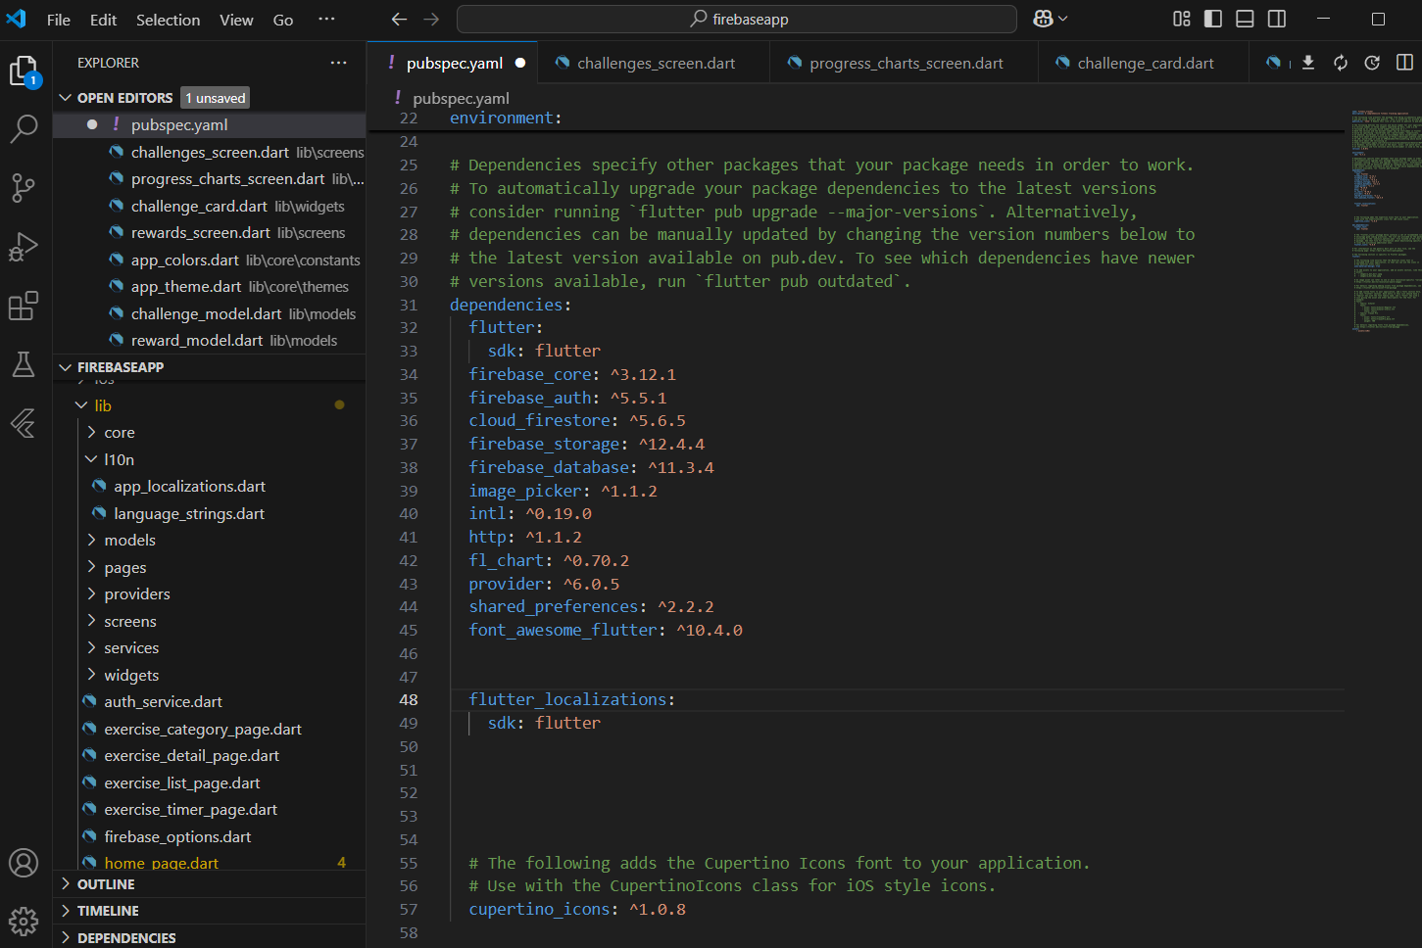

• Widgets → Used for buttons, text fields, cards, and animated icons.

• Stateless and Stateful Widgets → Stateless for UI components, Stateful for dynamic data updates.

• Styling and Theming → Applied custom themes and fonts for a consistent look.

• Layouts and Views → Used Column, Row, Stack, and ListView for structured UI.

• Navigations → Implemented Drawer and BottomNavigationBar for seamless navigation.

• Gestures → Used tap and swipe gestures for interactive elements.

• API Calling → Fetched motivational quotes ,exercise info and nutrition data from APIs.

• Database → Stored weight tracker and exercise logs in Firestore.

• Firebase Integration → Used Firebase Authentication and Firestore for data storage.

• Localization → Integrated flutter_localizations for multi-language support.